SUMMARY

The document describes how to use “MKS Source Integrity” for software development to be conform to Autoliv Software development process.

EVOLUTION OF THE DOCUMENT

Issue Date Author Motive and nature of the modifications

A April 30, 2009 J. Lacroix first edition.

CONTENTS

1. OBJECTIVES 3
1.1 Object 3
1.2 Application field 3
2. LIST OF RELEVANT DOCUMENTS 3
3. TERMS 3
4. MKS Source Terms 4
5. General information 6
5.1 General description 6
5.2 Specific rules for use of MKS 6
6. Advanced Project Management 7
6.1 Scope 7
6.2 Development Path 7
6.3 Add Shared subproject 10
6.4 Configure subproject 11
6.5 Example of a complex project creation 13
7. Description of Actions in MKS Source Integrity 16
7.1 Drop a subproject 16
7.2 Re-add a subproject that has been dropped 18
7.3 Configure subproject 20
7.4 Create a development path 22
7.5 Restore project to a previous checkpoint 24
7.6 Move label on project 27
7.7 Delete label on project 29
7.8 Move label on member 30
7.9 Delete label on member 31
7.10 Drop member 32
7.11 Downgrade or Remove other user lock 33
8. How to work with MKS Source Integrity 36
8.1 workflow 36
8.2 Project tree structure 37
9. Allowed actions for MKS Advanced users 38

This document contains: 39 pages.

OBJECTIVES

Object
The document describes how to use “MKS Source Integrity” for software development to be conforming to Autoliv software development process.
It should be used by software engineers with advanced knowledge as:
- a guide for advanced project management in MKS
- a description of all actions allowed for Advanced users and denied to SW users

Application field
In MKS, 3 kinds of users are defined, depending on skill:
- Normal User (Software Engineer)
- Advanced user (Software Leader, Design Leader…)
- Administrator
This document is dedicated to Advanced User. It should be used in complement of the “Normal User” Local Instruction. It described more advanced actions available only for users who need to manage projects.
Another local instruction exists for Normal users, it describes all day to day actions for SW engineer work in MKS.

LIST OF RELEVANT DOCUMENTS

Nb | Document | Reference | Company
[1] | Configuration Management | SW014 | AEE-C
[2] | Software coding rules | SW001 | AEE-C
[3] | SW Configuration Management Plan | AEF 1071 t/A | AEE-C
[4] | Use of MKS for Normal users | SW054 | AEE-C

TERMS
ALV: Autoliv
ALE: Autoliv Electronics
SCM: Software Configuration Management
SW: Software
DVPT path: Development Path

MKS Source Terms
administrator The administrator installs MKS Source; defines and customizes projects and policies; and creates and manages user accounts, allowing users to access the program.
archive description The archive description contains text that describes the purpose of an archive. Each time you create an archive, you can assign a description to it.
archive An archive is a file containing the history of a member (a record of all the changes made to it since it was put under revision control). From the information contained in the history, MKS Source can reconstruct any previous version of the member.
branch A branch is a revision path that diverges from the main line of development (or trunk) in a member or project history.
change package A change package is a group of changes made by a single user that can be considered a logical unit of work. Only the creator of a change package can add entries to that change package. Change package entries are added when you specify a change package while performing member operations.
check in Checking in a member creates a new revision of a member and adds it to the member history. When a member is checked in to a revision other than the head revision or a branch tip revision, a new branch is created.
check out Checking out a member extracts the contents of a revision in a member history and copies it to the working file. You can check out any revision by specifying either its revision number or label.
checkpointing Checkpointing a project creates a new revision of the project and adds it to the project history. When you checkpoint a project, you save all the information needed to recreate the project completely as it existed when you checkpointed it. The saved information includes the project structure and the list of members with their revision numbers.
development path A development path is an identifier given to a new branch of software development. Changes made through the new development path are kept separate from the main development trunk unless you choose to merge them later.
drop (member/subproject) Dropping a member/subproject remove it from the project. After you remove a member/subproject from a project, the member/subproject is no longer listed as part of the Sandbox or master project, but the member/subproject’s history remains in the project record, in case you need to recreate an earlier version of the project.
freezing Freezing a member places it in a state that prevents changes from being made to the member information that resides in the project file. For example, you cannot update the member revision or change the attributes of a frozen member. Freezing is the opposite of thawing a member.
importing (a project or member) Importing a project or member registers it with the MKS Integrity Server. Once a project or member is imported, MKS Source commands can be performed upon it.
lock A lock is a feature of MKS Source that controls how changes are made to revisions. When a change is checked in, it requires the revision being updated to be locked, in order to prevent more than one user from simultaneously checking in changes to the same revision.
member (former) A former member is one that is dropped from the project, but still has a working file in the Sandbox. MKS Source retains the member history for former members as part of the project. Depending on the options you select when dropping the member, MKS Source can also delete the member’s working file and close any associated change package.
member revision The member revision is the default revision that users work with in all other Sandboxes. For example, if demoapp.c 1.1 is the member revision, setting 1.2 as the member revision makes it the default revision in all Sandboxes.
member The files under version control in a project are known as members. pending member / subproject A pending member / subproject, is a member or subproject that is associated with a pending operation that adds it to the project. The pending member or subproject is denoted by a pending icon in the Name column of the Sandbox and Project views.
project An MKS Source project is any group of files under version control that, taken together, forms a single body of work.
resynchronizing To update out of sync working files to the most current member revisions, you resynchronize the members.
reverting Reverting a member discards any changes made to a member’s working file since it was checked out, and then unlocks it.
revision (Head) The head revision is the top revision on the default branch or the trunk, if no default branch is defined.
revision description A revision description is text that becomes a permanent part of the archive’s metadata. It allows you to provide a record of the changes you made and why you made them. This can be of great value to you or other team members if it ever becomes necessary to revise or update the member.
revision label A revision label is a textual name that describes and refers to a revision. When a member is checked in, you are given the option of assigning it a revision label. Labels can be based on the product release the revision was included in, on the content of the revision, on changes made to the revision, or any other sort of information that would be useful in identifying that particular revision. Revisions in a history can be displayed and selected either by revision number or revision label.
revision number Each revision is assigned a unique revision number used to identify a revision in a history. Revisions on the mainline are numbered as two-part decimals (such as, 1.1, 1.2, 1.3, 1.4 …). Revisions on a branch are numbered by adding two-part decimals to the number of the revision they branch from. For example, if a branch is started from revision 1.3, its revisions would be numbered 1.3.1.1, 1.3.1.2, 1.3.1.3, and so on.
revision A revision is a version of a file and is contained in a history. A new revision is produced in the history each time a working file is checked in.
Sandbox A Sandbox is a private workspace that resides on the client machine and mirrors the content of a project on the server. Although it looks and acts like the project it mirrors, a Sandbox is actually a collection of pointers to its real-life counterparts in the master project. Sandboxes allow you to work locally in your own workspace, without interfering with the work of others.
Sandbox (build) A build Sandbox is a Sandbox associated with a particular project checkpoint and has no development path (since it is static and not meant for further development). No further development can be carried out in a build Sandbox.
Sandbox (variant) A variant Sandbox is based on a specific development path of a project. When you create a variant Sandbox, you choose the development path to use. In the variant Sandbox, you can see the current state of the project along that development path and the changes made by other developers using it.
thawing Thawing a member removes the restriction on changing member information in the project and makes previously checked in member information available to the project. Thawing a member is the opposite of freezing a member.

General information

General description
A general description for:
- MKS,
- Version Control,
- Software Configuration Management (SCM),
- General project and sandbox management,
- Checkpoint management,
can be found in the local instruction SW054 for Normal users.

Specific rules for use of MKS
Pending: many actions in MKS could be “pending”, it allow you to delay this action. Action is not applied immediately on the project, but pending actions could be applied later at the same time. You can store some modification for a later implementation. This feature is not used in AEE/C.
Issue/Item management and Change Package: For all actions in MKS it’s mandatory to have a Change Package. The Change Package could be create from an Issue/Item in “MKS Integrity Manager” or directly in “MKS Source Integrity”. If your project is managed under “MKS Integrity Manager”, it is MANDATORY to create the Change Package directly from an Issue/Item.

Advanced Project Management

Scope
There are a variety of ways to manage project:
In easiest case, project is a stand alone project – MKS is just used to keep trace of whole development.
For some developments, project is based on one or more existing projects. If the original project is still under development, you can decide to get all new modifications of the original project in your new development project, or you can decide to begin development at a defined past checkpoint of original project (each development will be independent, but modifications done on a project can be seen and carried on other project). You can also decide to import in your new project only defined sub-project of original project (like a kernel, used as base for all development in a specific platform).
MKS provides many actions and commands for project management, in next chapters, we will have a description of each, with actions and results on project. Then we will describe several cases on how to use them.

Development Path
A development path is an identifier given to a new branch of software development. Changes made through the new development path are kept separate from the main development trunk unless you choose to merge them later. A development path has its own set of member revisions, independent of the trunk or other development paths. This allows you to have member revision on the development path different from the member revision of the trunk.
Once you have created a development path, you can open and work in a variant project by opening a variant Sandbox.
This is a typical project development, a file was modified between project revision 1.2 and 1.3, and a new file was added in project revision 1.4.
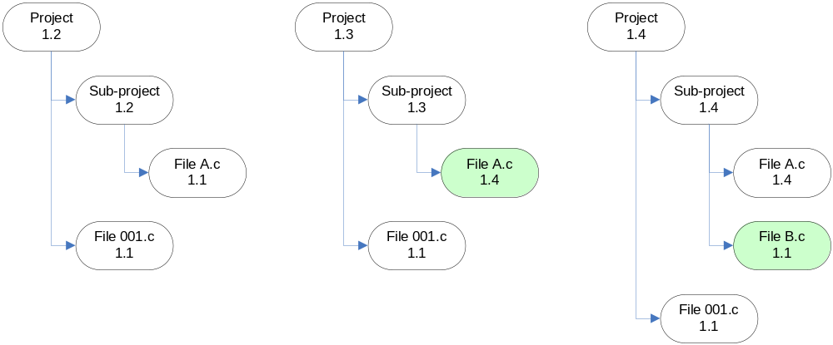
From revision 1.4, the software pilot decides to create a development path for a specific evolution in software.
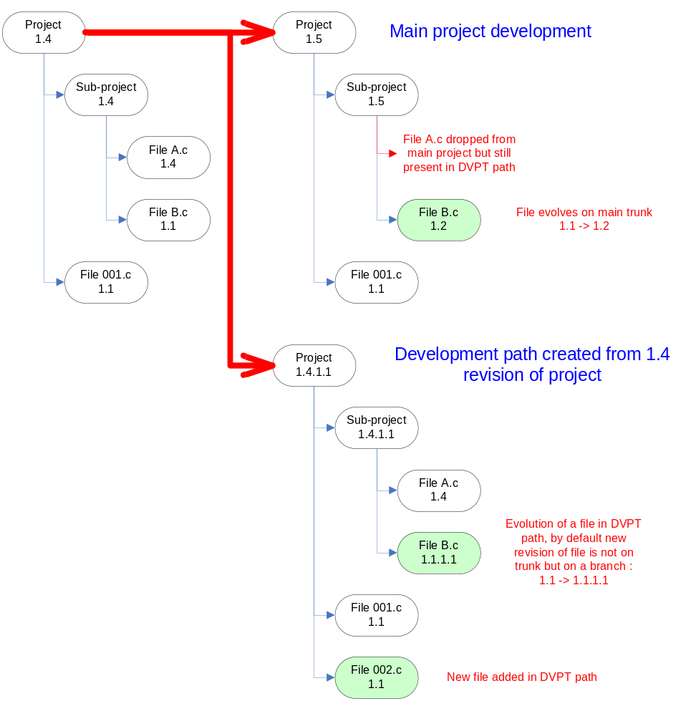
As you can see, the development path creates an image of the project on a separate branch, modification on a branch will not impact trunk and vice-versa. The file “FileA.c” dropped from main project is still present in DVPT path, file added in the DVPT path is not present in main project and files can evolve separately (like “File B.c” in example).
But all files in project (trunk and branch) will have a common history, to avoid conflict, when you check-in a file in a DVPT path, it will create a branch in the file history(if “create branch if variant” is activated during check in).
You can also decide to apply modifications between DVPT path and trunk, for example, you can add “File 002.c in the trunk for next project revision, or decide to use the revision 1.2 of “File B.c” in the DVPT path.
When using development path, you must use Change Package for each modification done on project, subprojects or members. Then, it is very easy to apply modifications between DVPT path and trunk with “Apply Change Package” command.
When do you need to use Development path:
- Case 1: when the trunk is considered as a generic development (common platform) and each development path is an application of this generic development
- Case 2: when your new development is based on a specific revision of an existing project
- Case 3: when a specific evolution is needed on a dedicated version of project (need to do instrumentation on a delivered version, need to test a specific evolution in a past configuration of the project…)
- Case 4: for each iteration of the project, a development path can be created to add all modifications, then, when the project need to be delivered, only needed change packages from development path are applied on trunk, and main project is checkpointed.
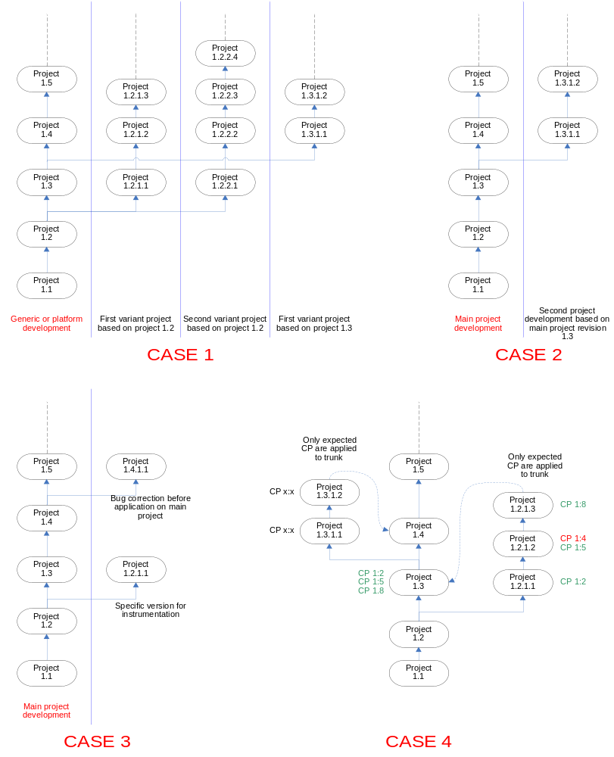

Add Shared subproject
A shared subproject is a subproject that is a member of more than one project. MKS Source allows you to share a subproject between two or more projects by referencing the original subproject. A shared subproject allows you to access common members across many projects.
A shared subproject functions the same as an unshared subproject and is accessible by the same commands. The shared subproject continues to reside within its original master project, but is referenced by the other project and shown as a shared subproject (a hand icon appears on the folder icon in MKS view).
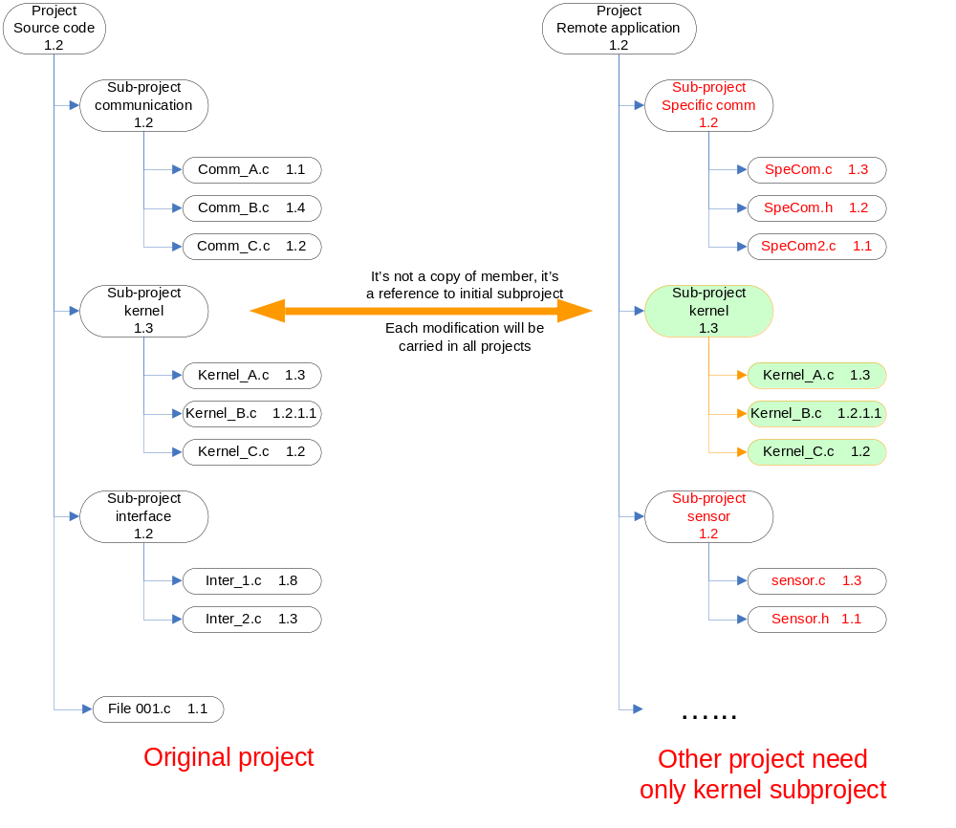
When you add a shared subproject to your project, you must select which type of subproject you want to import (normal, variant, build). You can read chapter “Configure subproject” in this document to have more information on different sub-project type, when to use them and how to change them later in the project.

When you add a normal or variant subproject to your project, each modification done in original subproject will be carried to your own project, and vice-versa, as they shared the same member revisions -> Be careful that modification can be used in all projects before delivery! Use “Freeze”/”Thaw” command to prevent unexpected member revision evolution
If a development path exists in the subproject, you can select a variant revision when adding it. In this case, modifications on your project will impact the member revisions of the development path.
When you add a build subproject, members of the subproject can not be modified: checkout/lock are denied.

Configure subproject
Once you create or add a subproject, you can modify the type to suit your needs. For example, you can change a normal subproject to a build subproject to suspend development, or you can change a variant subproject to a normal subproject to continue development on the main trunk.
Any changes you make when configuring a subproject affects the project as a whole and any subprojects within it (except shared subprojects that must be configure manually). If you configure a subproject in your sandbox it will also update the project on MKS server and all sandboxes generated from it. Be sure of effects/impacts when you do a change in subproject configuration.
For example, here is a development in a project: From an initial Project checkpoint (1.4), development continues on the trunk (1.5) with modification/drop of file, and a development path was created (1.4.1.1) for a specific need.
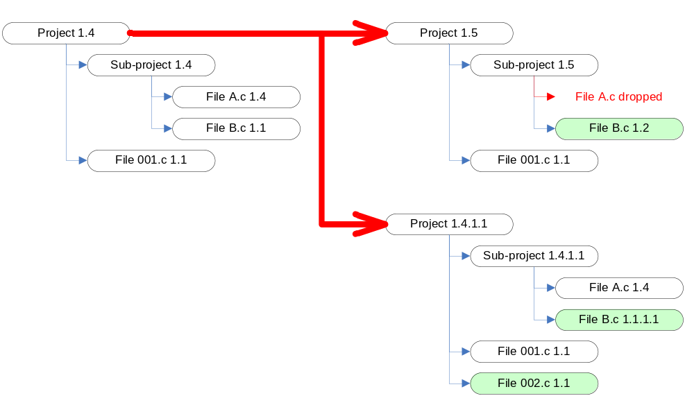
Nothing was done on trunk after checkpoint 1.5, so if you create a “Normal Sandbox” it will appear as Project 1.5 on graph. In this project, you can need to use variant subproject instead of normal subproject. The original subproject will be replaced by the variant and members will be populated according to variant. If a modification is done on a member in subproject, the evolution will be registered in the development path tree of variant sandbox.
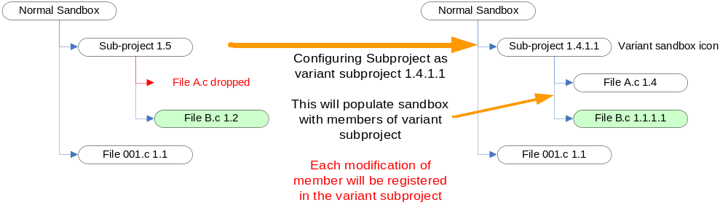
You can also need to “freeze” the development in a subproject to a past revision of subproject. To do that, you can configure this subproject to the build revision corresponding to your need. Subproject members will be updated according to this build revision. Take care that when you configure a sub-project as a build subproject, it can not be modified anymore: checkout and lock commands are denied.
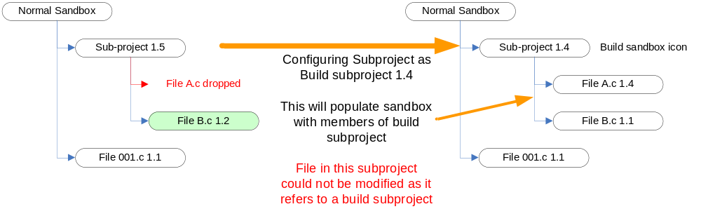In a development path, you can also decide to stop development in a subproject and synchronize it to the development done in the normal project. In that case, configure the subproject as a normal subproject. This action will synchronize the member to the current member revisions on the normal subproject. Any modification done in normal development (trunk) will appear in subproject and vice-versa.
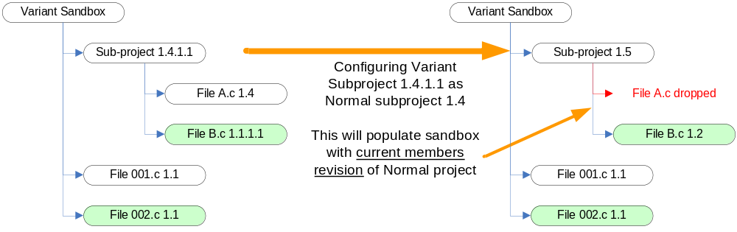Deltas reflecting these changes appear in the Project or Sandbox view. Some differences you may see include:
- Members existing in the original version and configured version of the subproject display a delta if the working revision in the Sandbox is different from the new member revision.
- Members that did not exist in the original version of the subproject, but do exist in the configured subproject, display a delta to indicate that the Sandbox does not have a working file for the new member.
- Members that existed in the original version of the subproject, but do not exist in the configured subproject, display as former members.
- Subprojects that existed as members in the original version of the subproject, but do not exist in the configured subproject, display as former subprojects.
To resolve the differences, resynchronize the subSandbox.
When configuring shared subprojects, remember that each shared subproject is configured independently. This means that when you configure a shared subproject, the reconfiguration does not change all instances of that subproject.

Example of a complex project creation
To summarize project creation and sharing, here is an example of a full complex project creation.
A new project must be created “vehicle T12x”:
- It’s a development based on an already existing project: “vehicle T10x”. A variant project must be created from checkpoint 1.4 of the project “vehicle T10x”.
- The customer communication protocol must be exactly the same as the one used on “vehicle T10x”, each evolution must be present in both project.
- Algorithms used in projects are developed by another team. This team delivers new releases regularly, but our new project must use a fully validated defined revision of algorithm: AG12.
- The “Kernel RTC” used on “vehicle T10x” should be removed, and the new kernel (Kernel GHS) must be added from a dedicated project.
- A new subproject must be created, it contains files for configuration of the new kernel, it is named “kernel configuration”
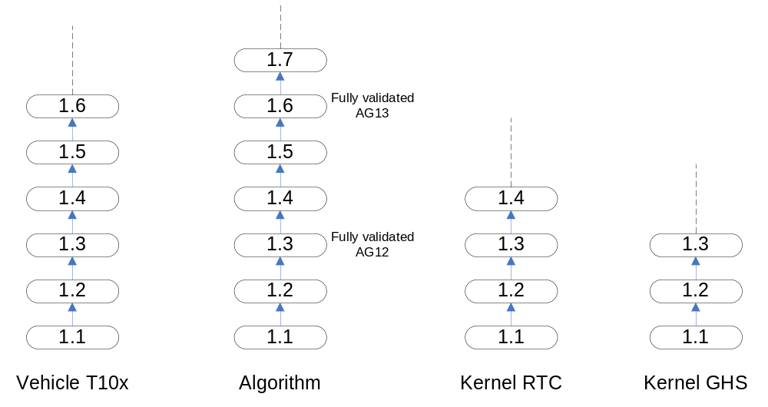
Here are the projects that already exist:
“Vehicle T10x” project which will be the base of the new project,
“Algorithm” project (Checkpoint 1.3 is the fully validated revision of algorithm AG12),
“Kernel RTC” which is used on “Vehicle T10x” project
“Kernel GHS” project which must be used on new project
The first evolution is to create the new project as a development path of existing project in checkpoint 1.4:
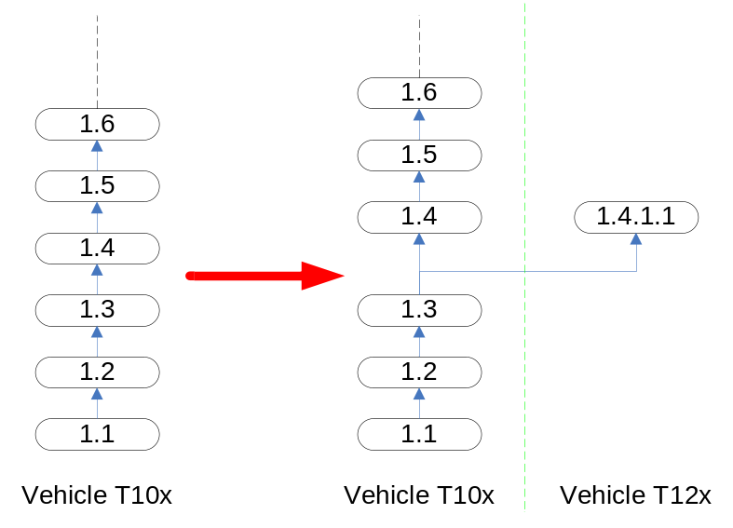
Then, 8 steps are required to define project:
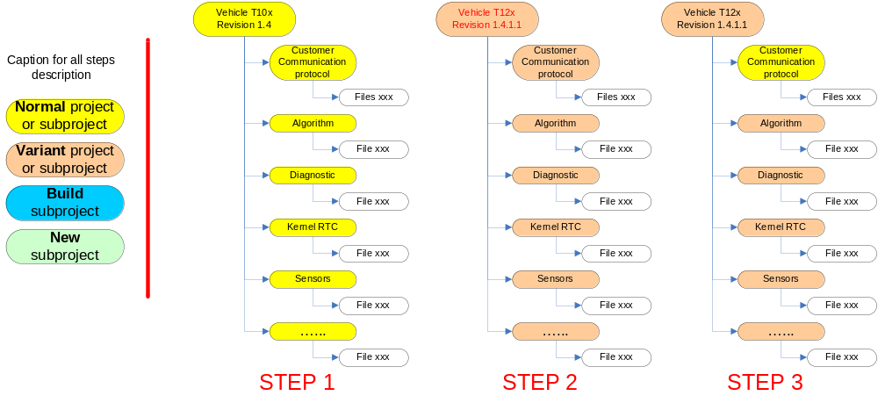
- Step 1: this is the original project before development path, all subprojects are supposed to be “normal” subprojects
- Step 2: this is the variant project 1.4.1.1 define from project checkpoint 1.4. All subprojects are defined as variant subprojects.
- Step 3: as “customer communication protocol” must be the same as used on current “Vehicle T10X” project, use the “configure subproject” command to define it as the “normal” subproject.
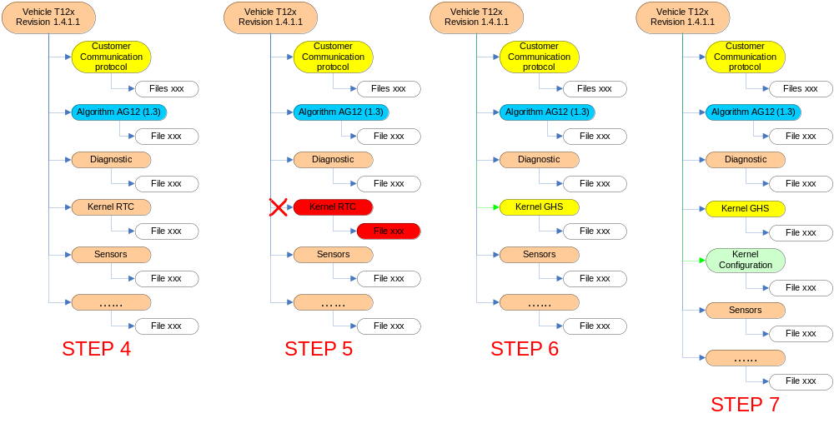
- Step 4: as algorithm to be used on project is revision “AG12” (MKS checkpoint 1.3), use the “configure subproject” command to define the “Algorithm” subproject to the build checkpoint 1.3.
- Step 5: “Kernel RTC” will not be used anymore in the project, you should use the “drop subproject” command to drop it from the “Vehicle T12x” project.
- Step 6: use the command “add shared subproject” to add the new kernel subproject “Kernel GHS”. In our example, “Kernel GHS” is added as a “normal” subproject to benefit of all development/corrections done on the original project even after added to our project. As needed, it can be configured as a build subproject to freeze a defined revision of the new kernel.
- Step 7: use the command “create subproject” to create the new subproject “Kernel Configuration” and populate this subproject with files according to your needs.
- Step 8 : last step (not represented but recommended) : checkpoint the new state of the project in order to have a snapshot of the original configuration of the project → checkpoint 1.4.1.2 will be created.

As there is many ways to create the project and subprojects structures, to have an easiest understanding of the project and for better maintenance, following rules must applied:
- The complete structure of the project must be described in details in the “Configuration Management Plan” of your project.
- ALWAYS track project structure modification in a change package. Each time you create/drop/configure/add a subproject, you must select a Change Package entry (which has a fully understandable description).

Description of Actions in MKS Source Integrity
In MKS Source Integrity, most of the commands can be accessed by 3 or 4 ways:
- For each command, a menu exists
- For frequently used command, they are present as icon in the toolbars
- Some commands can be found in the contextual menu of the item (right click on the item – project, sandbox, member…– to access contextual menu)
- Some commands have a specific hotkey: F5, F6, F7…
Toolbars and contextual menu are customizable by users.
In the rest of the document, “command” will refer to the standard menu item. It will be displayed as “menu > sub-menu1 (> sub-menu2…) > command”, and hotkey will be added when it exists.
For all basic actions, a description can be found in the MKS Normal User local instruction, this document list and describe only actions denied for normal users and allowed for advanced users.
To summarize the list of allowed actions available only for advanced users (see chapter 9 in this document), advanced users can dropped/re-add/configure subprojects, create development path, restore project to a previous checkpoint, move/delete label on project and members, drop members and downgrade/remove lock from other users.

Drop a subproject
If a subproject has outlived its usefulness or just does not belong in a project anymore, you can remove it at any time.
You can drop a subproject from project view and sandbox view, but to avoid inadvertent unexpected drop on other project, we recommend doing it ALWAYS from your sandbox view.
Before dropping a subproject, be sure to be in “My sandboxes” view and to be on the subproject you want to drop. If you have opened the sandbox, you can also select this subproject directly in the sandbox.
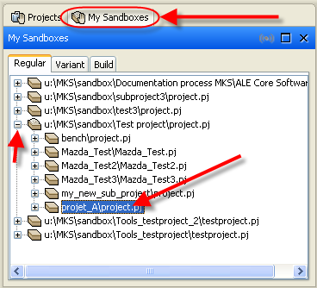 or 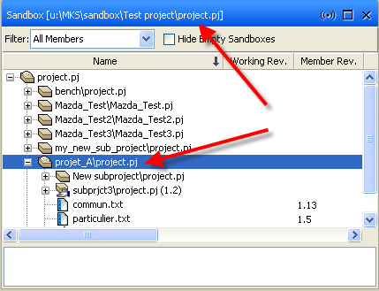

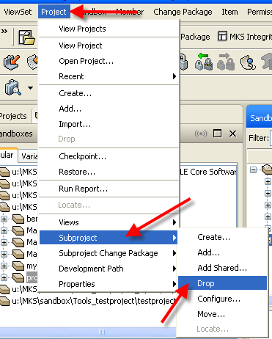 Then go to menu “Project > Subproject > Drop…”.
In the popup window, always select a valid change package with an understandable description or create one, then validate with OK button. As it is a major change on project, a confirmation popup window must be validated:
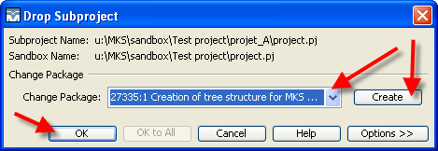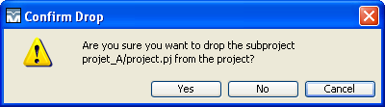
Sandbox view will be updated (subproject no more visible) and project will be remove from other users sandbox on resynchronization.
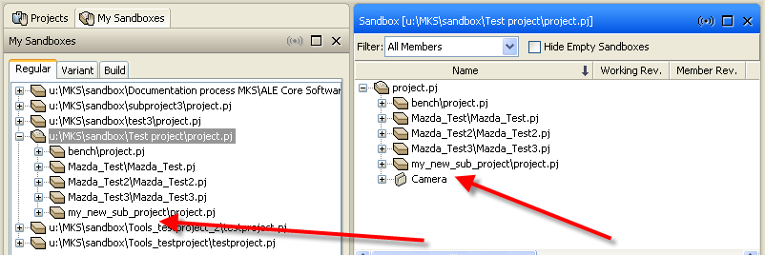
IMPORTANT: When you remove a subproject, you also remove all members within that subproject.
Files will be removed from your computer hard drive too.

After you remove a subproject from a project, it is no longer listed as part of the Sandbox or master project, but the subproject’s history remains in the project record, in case you need to recreate an earlier version of the project.
You can need to re-add a dropped subproject, see chapter below to know how to do it.

Re-add a subproject that has been dropped
When a subproject is dropped from a project; the subproject’s historical information remains. You can add the subproject back if needed.
To re-add the subproject, you must know the name of the dropped subproject, where the subproject was in the project structure and what kind of subproject it was (normal, variant, build). For shared subproject, project must be re-add from original subproject (as shared subproject, file are not stored in your project structure but in the original one).
For this example, we will restore the project “Test project\projet_A\project.pj” (dropped in previous chapter) and re-add it as a normal subproject.
Open your sandbox and expand tree structure to where subproject must be added. Then go to menu “Project > Subproject > Add…”.
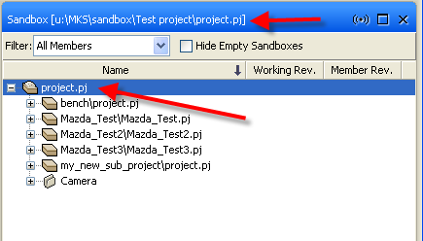 then 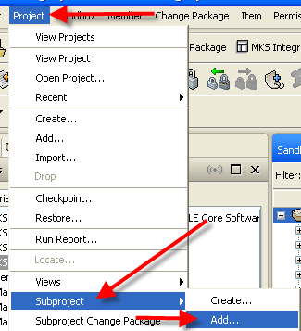
The Add Subproject Wizard windows opens, hit select button to browse for your subproject to add.
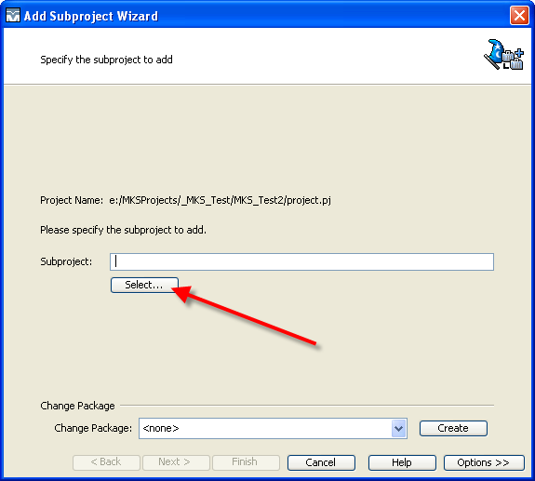
Go to correct directory and select subproject to restore.
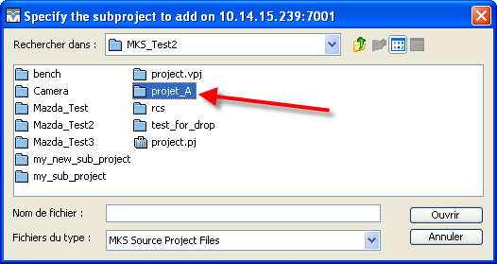 then 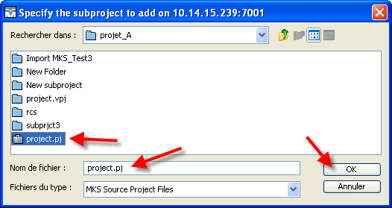
Always select a Change Package or create a new one. Then, press “Next>” button.
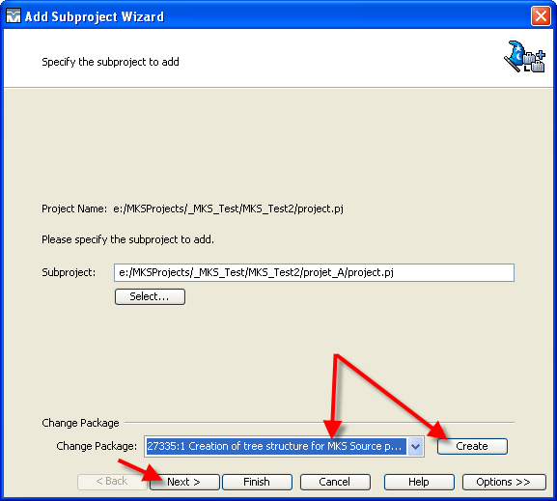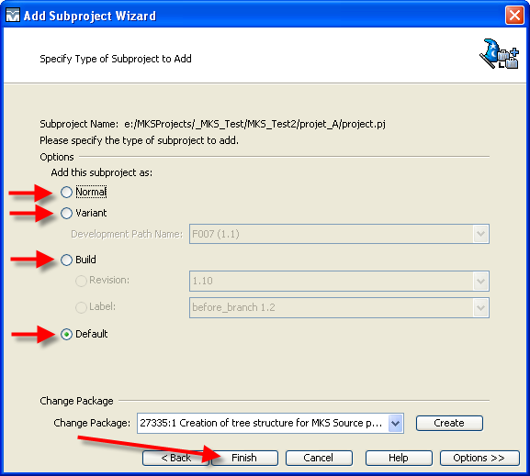
You must select the type for the subproject (See chapter 6.4 to have more information on subproject types). “Default” will select the same type as project/subproject where importation is done. Then press “Finish”. You can check in your sandbox view: project is restored.
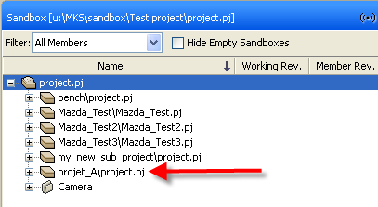
The type a subproject is not memorized when subproject is dropped. Be sure to import it in the same type as it was before. This is why it’s very important to always track creation of project tree structure and drop of subproject in change package, and to have this information in the “Configuration management plan” of your project.

Configure subproject
Any changes you make when configuring a subproject affects the project as a whole and any shared subprojects within it. If you configure a subproject in your sandbox it will also update the project on MKS server and all sandboxes generated from it. Be sure of effects/impacts when you do a change in subproject configuration.
You can find more information on different types of subprojects and why to configure them in chapter 6.4.
If you need to configure a subproject, open your sandbox and select the subproject you want to configure:
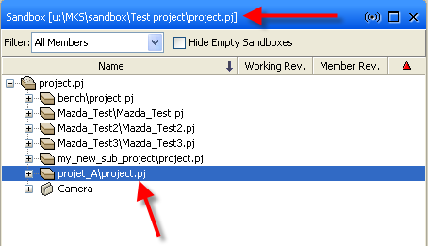
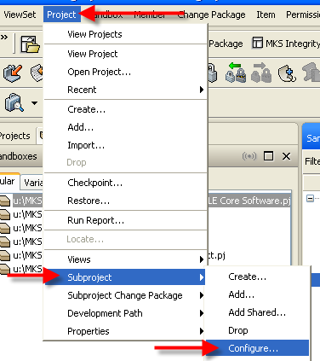 Then go to menu “Project > Subproject > Configure…”.
The Configure Subproject window is displayed.
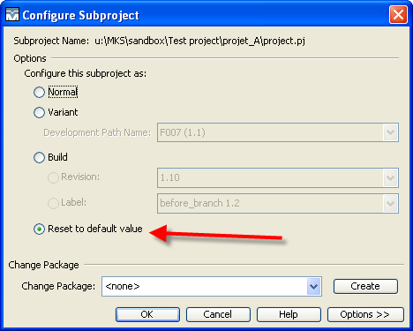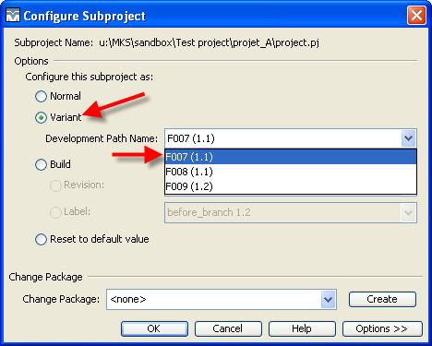
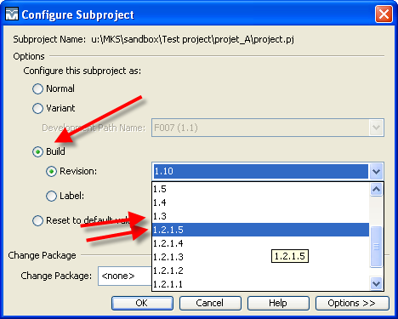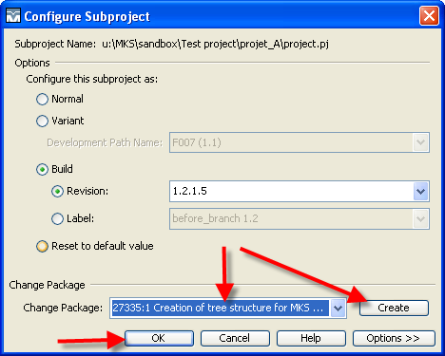
When window appears, it displays the current configuration of subproject. “Reset to default value” will use the same type as parent project/subproject. You can configure it as Normal subproject, or as a variant subproject (select which development path to use) or build (choose the Revision or Label, are listed here all build revisions for normal development and development paths). When you have selected the good one, add a Change Package or create a new one, then press OK to validate.
The Sandbox view is updated. In the example below, the two subprojects are not present in the new configuration, they will be removed after a synchronization of the sandbox.
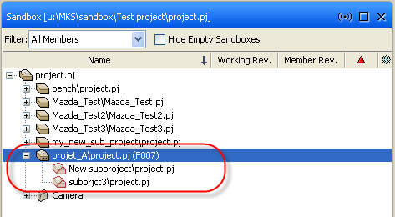 -> 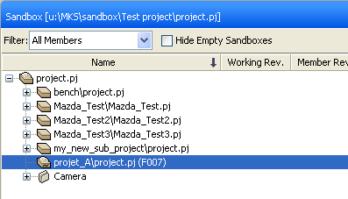

Create a development path
You can find more information on Development path in chapter 6.2.
Note: You can create a Development path on the project or on a subproject and you can create as many development paths as you want.
To create a Development path, you can select the project or subproject in your “My Sandboxes” view or in the sandbox:
Note: You must open the project that is configured in "Normal". For some obscure reason, the creation of development path is not accessible from a project configured in "Variant" or "Build".
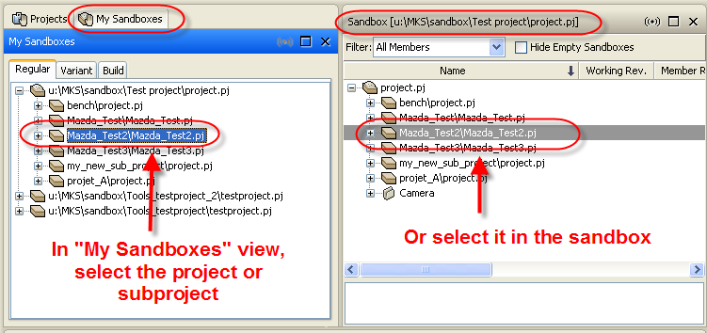
Then open the project/subproject history view with menu “Project > Views > View History”. History is displayed:
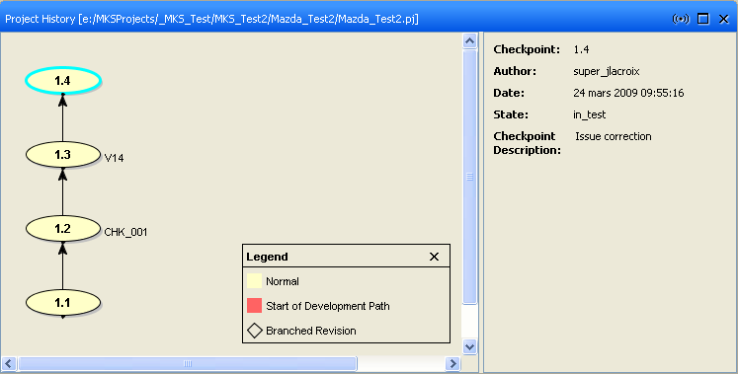
In the history view, select the checkpoint from which Development path must be created (1.2 on example below) and go to menu “Project > Development Path > Create…”.
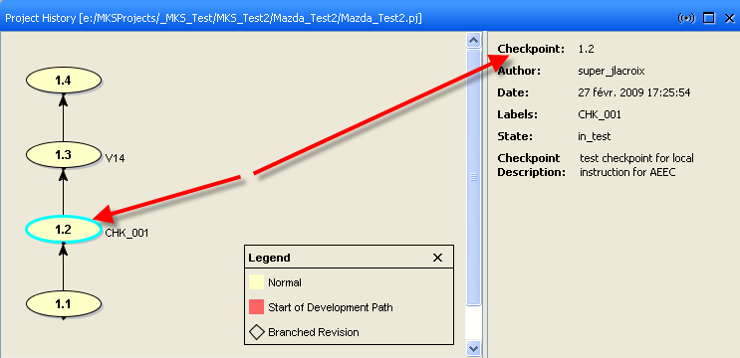 → 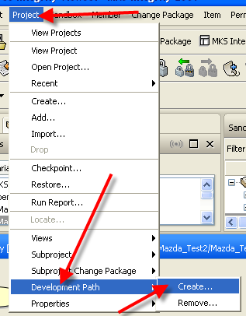
The revision you have selected is displayed, if it is not the good one, you can modified it in Revisions or Labels tab. Enter a valid name for Development Path (a name that can be understood easily by everyone, not only in the project) and press OK button.
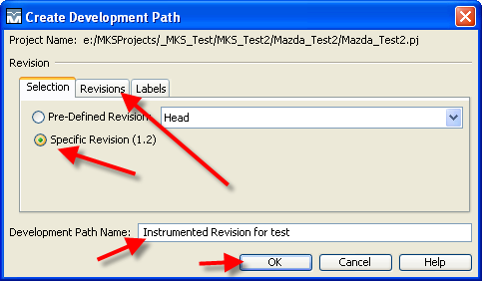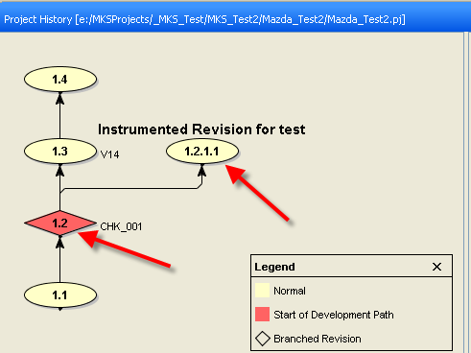
Project history is updated. The 1.2 revision is now displayed as a start of development path, and the development path is created as 1.2.1.1 revision.
It does not affect your project, sandbox is still based on the 1.4 project revision in example, but now you can work with your development path:
- If you create a variant sandbox on this project/subproject and select the development path.
- If in your normal project you configure your subproject to this variant.

Restore project to a previous checkpoint
This action should be used with care. It will restore the project or subproject to a previous checkpoint:
- All structure modifications in project (add shared/drop of subproject) will be removed.
- All members will be set as the member revision according to checkpoint. All added members will be removed and all dropped members will be restored.
- All modified members (not checked in) can be lost during synchronization.
This action will restore the project, so all sandboxes (for all users) based on this project will be restored too. Be sure of effects/impacts when doing this action.
For example, in following subproject “projet_A”: “subprject3\project.pj” was added with add shared command, file “commun.txt” was modified from revision 1.11 to 1.14 and file “particulier.txt” was checkout and modified (without check-in).
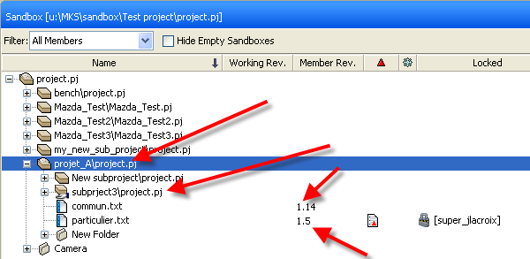
To restore a project select the project or subproject in your “My Sandboxes” view or in the sandbox:
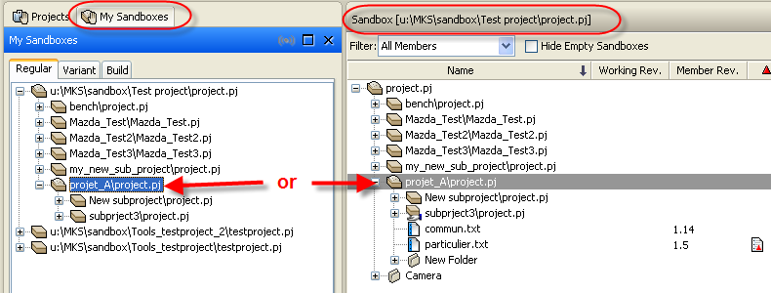
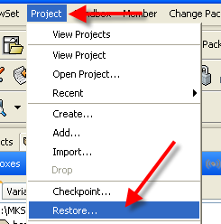And go to menu “Project > Restore…”.
By default, you will restore the “Head” which correspond to last checkpoint of the project. You can specify any checkpoint revision you want by selecting the good one in “Revisions” or “Labels” tab.
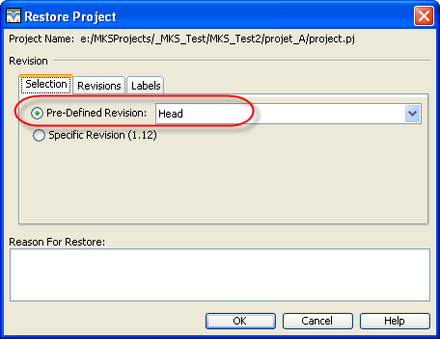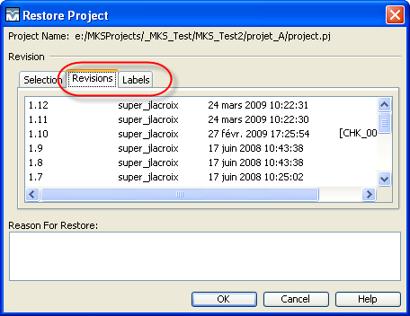
Enter a description for reason to Restore and validate: 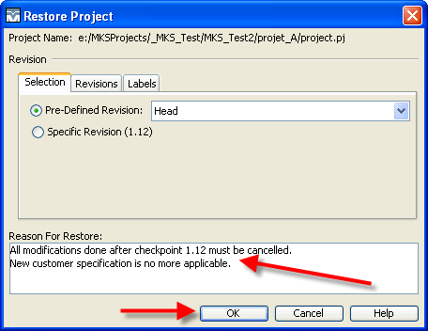
First, MKS performs a checkpoint of the current state of the project. Then, all members/subprojects are restored to their state snapshot during the restored checkpoint: added subproject is dropped, and member revisions restored. Finally, MKS performs a checkpoint of the restored project. So if for example the last checkpoint of your project is 1.5 and you want to restore checkpoint 1.4, you will have a checkpoint 1.6 which snapshots the state of the project when you perform the restore command and checkpoint 1.7 which is a copy of checkpoint 1.4.
As expected, your subproject is restored, but files in sandboxes are not up to date, use Resynchronize command to update your sandbox.
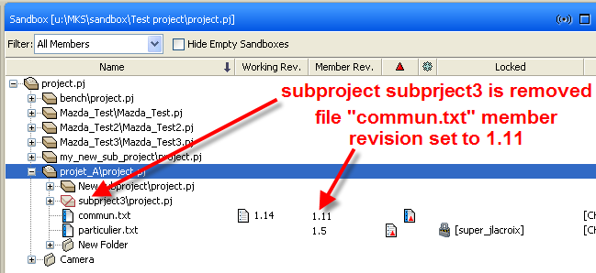 → 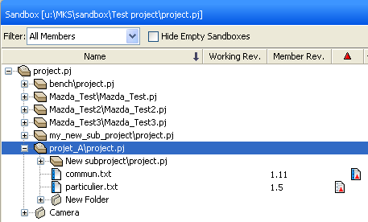
Note: modifications done on members (revision 1.12 to 1.14 of file “commun.txt”) are still present in the member history; only current “member revision” are modified.

Move label on project
There are two ways of moving project label, read the description of the two solutions to be sure to use the good one on your project
You can move a project label from a project revision to another project revision. In this case, the label is moved ONLY between project revisions and not between member revisions. This could be very confusing: you created a checkpoint with a label and applied the same label to all members (so, project revision and all members of this project revision have the same label) then if you move the project label to another revision, the label will not be applied on all member revision according to new project revision! You have to manually move label on each member that has been modified between the two project revisions (see chapter 7.8 for details on moving member labels).
To move label ONLY on project, open the project history of the project or subproject, and select the revision on which you want to move label. Then go to menu “Project > Properties > Add label…”
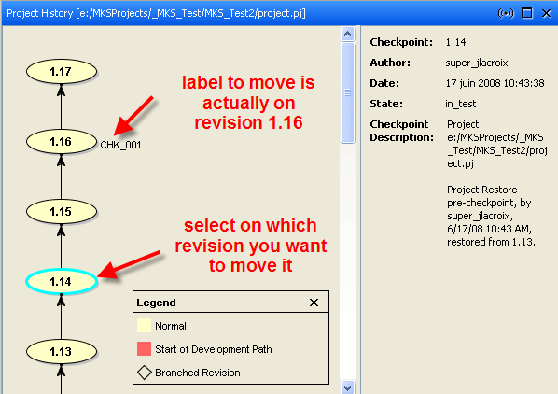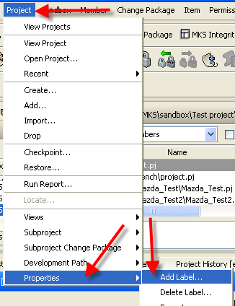
In the Add Project Label window, enter exactly the same label name and click on “Options >>” button to display options. Box “Move Existing Label” must be checked. Click on OK to validate. Label is moved to selected project revision.
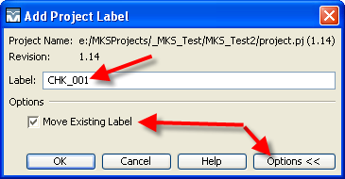 → 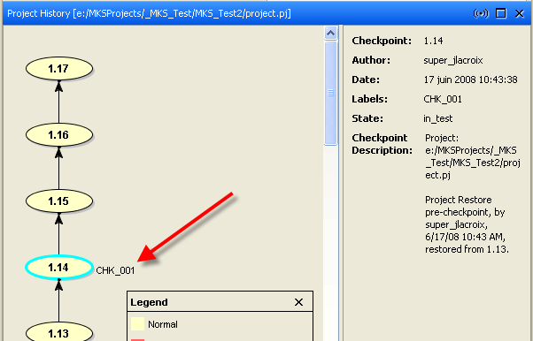
You can move a label from a project revision to a newer project revision during checkpoint of project. You have done a checkpoint on the project and applied the same label to all members. But some modifications were done on the project after checkpoint, and you want to do a new checkpoint on the project and applied the same label. In that case, during the new checkpoint procedure, the label will be moved from older project revision to new one, and will be moved to all member revisions. As advanced user, the command is allowed to you, but it’s denied to normal user of MKS.
See chapter on how to checkpoint a project in the “MKS normal user” local instruction for complete procedure. During the checkpoint, be sure to enter EXACTLY the label name you want to move and to select the box “Apply Label to All Members”.
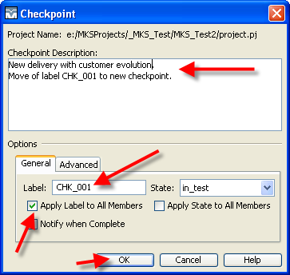
A new checkpoint is created in project history. Label is set to this checkpoint and to all members of this checkpoint.
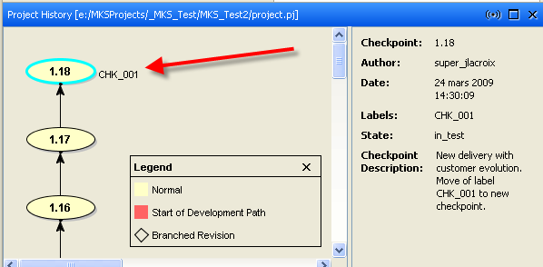

Delete label on project
Deleting a label on a project will not remove it from all members of this project, but ONLY from project.
In your sandbox view, select the project on which you want to remove a label. The go to menu “Project > Properties > Delete Label…”.
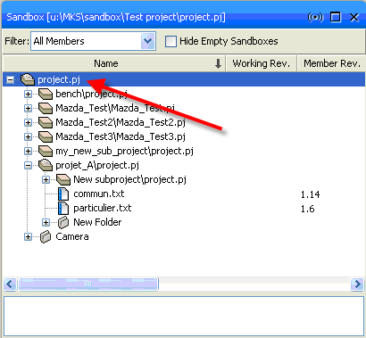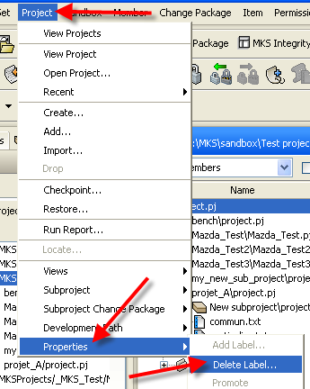
In Delete Project Label window, select the label you want to delete and validate with OK.
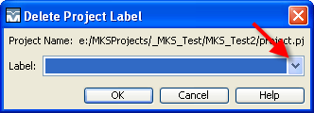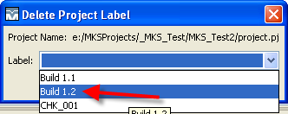
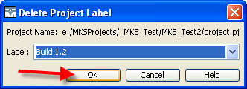
Label is removed from the project but is still present on members (if it applies to members). See chapter 7.9 to know how to remove it from members.

Move label on member
Moving a label from two revisions of a member will not change the checkpoint for those revisions. Example: label “BUILD 1.1” is applied to a project revision and all members of this project revision (revision 1.14 for file “test.c”). On file “test.c”, if you move the label from revision 1.14 to 1.16, a sandbox created to the project label “BUILD 1.1” will populate the revision 1.14, and not the 1.16! Label is only information.
To move a label between two revisions of a member, open the member history, select the revision for label destination and go to menu “Member > Properties > Add Label”.
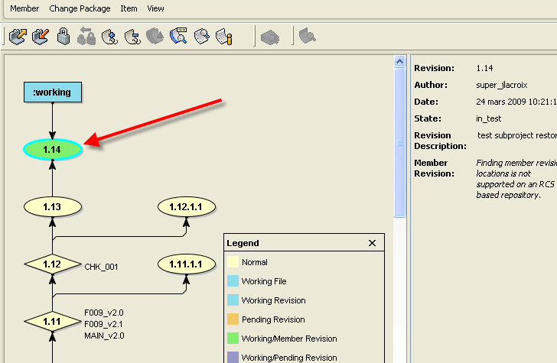 → 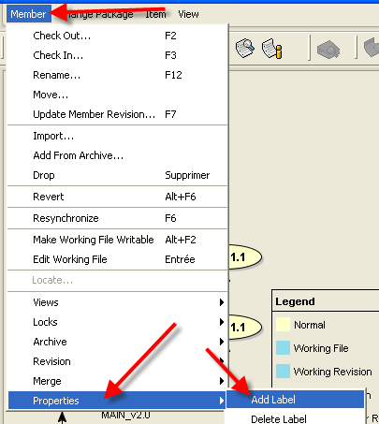
Enter exactly the same Label name. In options, you can force the move of existing label. If you don’t, a confirmation screen is displayed.
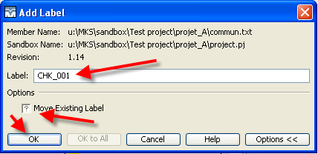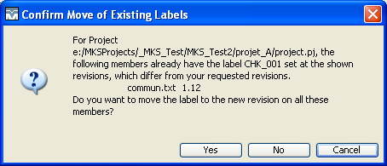
Member history is updated.
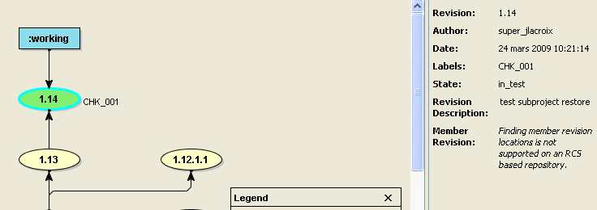

Delete label on member
To delete a label on a member: select the member in your sandbox view and go to menu “Member > Properties > Delete Label”.
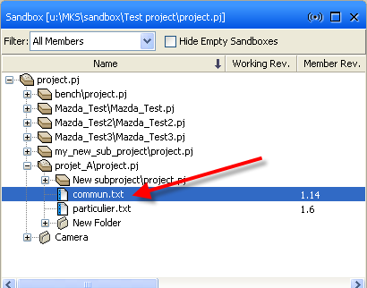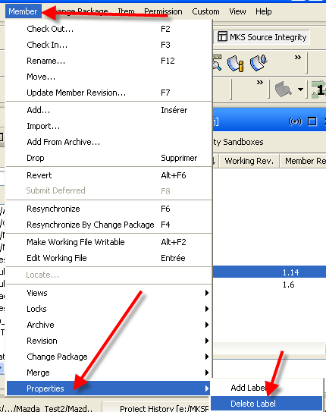
In the Delete Label window, select the Label name you want to delete and press OK.
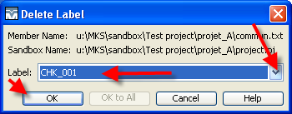
Label is removed from member.
Note: You can select multiple files and delete the label on all files with the same command. In that case, the “OK to All” button will be active and you can push it to remove label on all selected files.

Drop member
If a member has outlived its usefulness or does not belong in a project anymore, you can remove it at any time.
After you remove a member from a project, the member is no longer listed as part of the Sandbox or master project, but the member’s history remains in the project record, in case you need to recreate an earlier version of the project.
To drop a member: select it in the sandbox view and go to menu “Member > Drop”.
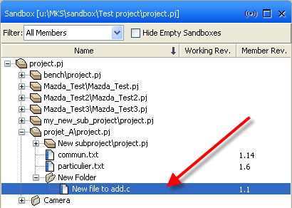 → 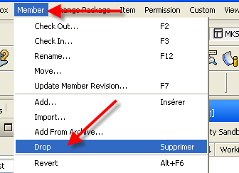
Select a Change Package or create a new one. And click on “Options >>” button to access options.
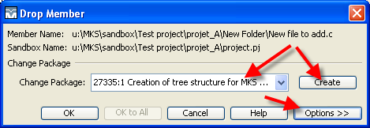
By default, this action will delete the working file in your sandbox directory on your hard drive. You will have to confirm the drop. Press OK to validate drop of member and Yes to confirm.
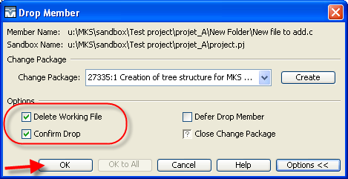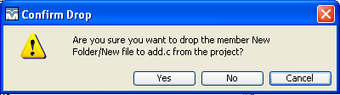
Member is nor more present in the sandbox view.

Downgrade or Remove other user lock
For several reasons, a user can have done an exclusive lock on a file and you (or another user) may need to access this file with exclusive lock. If the user is not present, as an advanced user, you have the ability to downgrade or remove the lock.
- If you downgrade the lock, user will still have a non exclusive lock on the member, he can do a check-in of its modification but he will have to do a merge if a new revision has been delivered.
- If you remove the lock and user has modified his working file in his sandbox, there is a risk for user to loose his modifications if he resynchronizes his sandbox.
It’s recommended to downgrade lock instead of removing it.
You can view a list of all members locked by a specific user, as long as they are in projects that you have permission to view. This is useful if you want to know what files a specific user is working on.
To view all files locked by a user, go to menu “Member > Lock > Find”. And in the Find locks window, enter part of the name of the user, select the correct user ID and press OK.
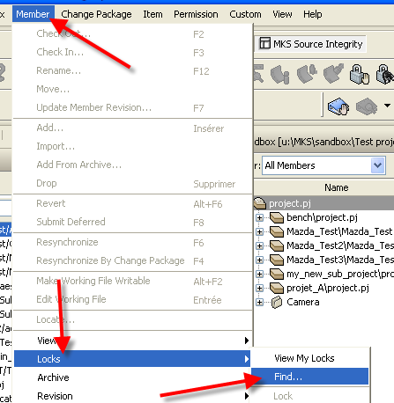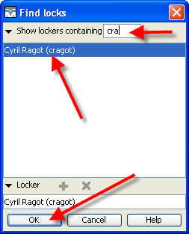
List of all locked files appear, with Project name, Member name and type of lock.
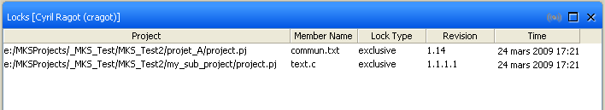
To downgrade a lock, select the line of the file you want to downgrade lock:
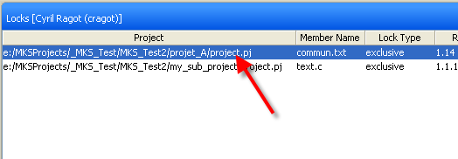
Go to menu “Member > Locks > Downgrade”. And validate the confirmation screen:
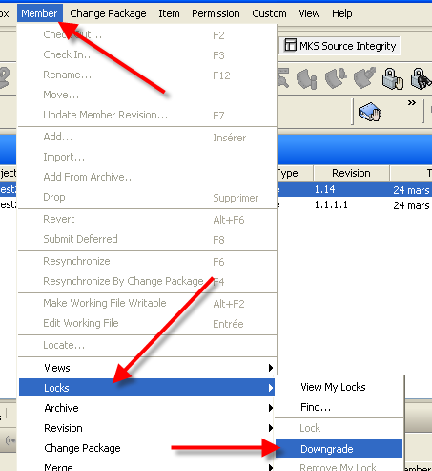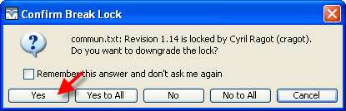
The type of lock is modified. You (or another user) can now do an exclusive lock on this file.
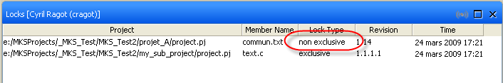
Note: to remove the member, select the file and go to menu “Member > Locks > Remove Lock”. Member will be removed from Lock screen.
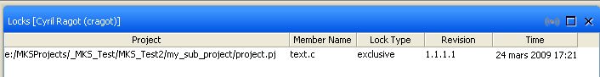
You can also downgrade a lock of another user directly from your sandbox view. In your sandbox view, select the member:
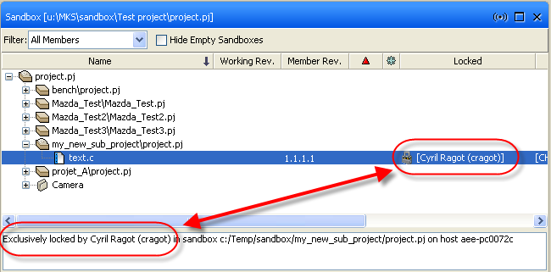
And use same menu “Member > Locks > Downgrade. A confirmation screen appears, validate it and lock is modified to non-exclusive.
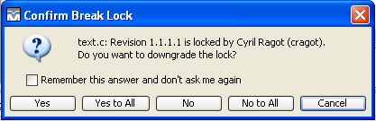
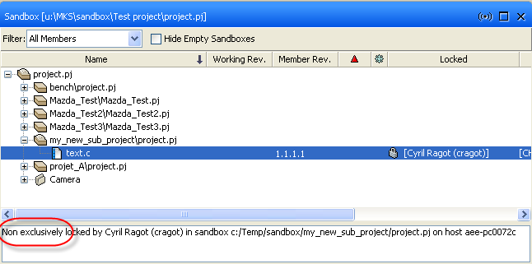
You can only downgrade lock in sandbox view, remove lock is only allowed in “find lock” view.

How to work with MKS Source Integrity

workflow
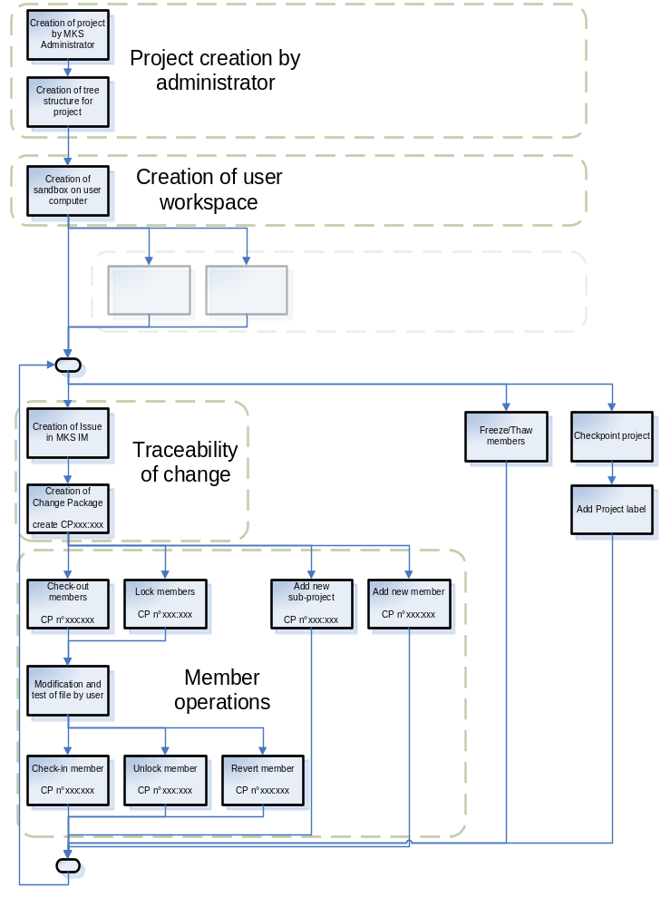

Project tree structure

Configuration_Item_View
→ Application | all configuration items related to the Application partition
→ Module | all configuration items related to the Module package/module
→ Design | all designs related to the Module package/module
→ Quality_Assurance | all quality assurance configuration items related to the Module package/module
→ Peer_Review | all peer reviews results related to the Module package/module
→ Polyspace | all polyspace workproducts related to the Module package/module
→ QAC | all QAC workproducts related to the Module package/module
→ Unit_Test | all unitary tests (module integration tests) related to the Module package/module
→ Architecture | all architecture configuration items
→ Document | the architecture documents
→ Peer_Review | the architecture peer reviews results
→ Bootloader | all configuration items related to the Bootloader partition → contains same structure as Application partition
→ Global_Integration_Tests | all configuration items related to global integration tests
→ Safing | all configuration items related to the Safing partition → contains same structure as Application partition
Development_View | all configuration items related to development
→ Source | all project source code
→ Application | all Application partition source code
→ Bootloader | all Bootloader partition source code
→ Safing | all Safing partition source code
Projet_Information | project information data
→ Application | project information data related to the Application partition
→ Quality_Assurance | quality assurance work products related to the Application partition
→ Metrics | metrics work products related to the Application partition
→ Peer_Review | peer reviews results work products related to the Application partition
→ Polyspace | polyspace work products related to the Application partition
→ QAC | QAC work products related to the Application partition
→ Releases | releases work products related to the Application partition
→ Executable | executable files related to the Application partition
→ Release_Notes | release notes related to the Application partition
→ Utilities | all utilities related to the Application partition
→ Build | build utilities related to the Application partition
→ Compiler | compiler utilities related to the Application partition
→ Bootloader | project information data related to the Bootloader partition → contains same structure as Application partition
→ Coverage_Analysis | coverage analysis related files
→ Safing | project information data related to the safing partition → contains same structure as Application partition

Allowed actions for MKS Advanced users
All MKS actions are listed below. In green are listed actions allowed only for advanced users. For all actions allowed also for Normal User, please refer to MKS normal user local instructions for detail.
Project Related |  | Advanced  User | Normal  User
AddMember | Add new members to project or import project through Sandbox. | Allowed | Allowed
ApplyProjectLabel | Add label to project. | Allowed | Allowed
Checkpoint | Check in new revision of project. | Allowed | Allowed
CreateSubproject | Create new subprojects. | Allowed | Allowed
ModifyMemberRev | Change member revision in project. | Allowed | Allowed
AddSubproject | Re-add dropped subproject to project. | Allowed | Denied
ConfigureSubproject | Modify type of subproject (whether normal, variant, or build) after created. | Allowed | Denied
CreateDevPath | Create new development paths for variants of project. | Allowed | Denied
DeleteProjectLabel | Delete a label from project. | Allowed | Denied
DropMember | Remove members from projects. Member archive remains, but member is no longer treated as part of project. | Allowed | Denied
DropSubproject | Drop one or more subprojects from server. Subprojects become unregistered subprojects. | Allowed | Denied
MoveProjectLabel | Move project label to another project revision within project history. | Allowed | Denied
RestoreProject | Restore project to particular checkpointed version. | Allowed | Denied
CreateProject | Project actions are allowed only for MKS Administrators | Denied | Denied
DeleteProject | Project actions are allowed only for MKS Administrators | Denied | Denied
DropDevPath | Project actions are allowed only for MKS Administrators | Denied | Denied
DropProject | Project actions are allowed only for MKS Administrators | Denied | Denied
Member Related
ApplyLabel | Add labels to revisions. | Allowed | Allowed
CheckIn | Check in working files as new revisions of members. | Allowed | Allowed
Freeze | Freeze members. When member frozen, no operations are run on frozen member revision. | Allowed | Allowed
Lock | Obtain an exclusive or non-exclusive lock on a revision. | Allowed | Allowed
MoveLabel | Move member label to another revision within member history. | Allowed | Allowed
Thaw | Thaw frozen members so operations can again be performed on member. | Allowed | Allowed
DeleteLabel | Delete label from revision. | Allowed | Denied
DowngradeOtherUserLock | Downgrade exclusive locks held by other users to non-exclusive locks. | Allowed | Denied
RemoveOtherUserLock | Remove locks held by other users. | Allowed | Denied
DeleteRevision | Delete revisions from member history. | Denied | Denied
Change Package Related
CreateChangePackage | create change packages. | Allowed | Allowed
MKS Integrity Permissions
CreateQuery | Create new query in MKS Integrity. | Allowed | Allowed
ViewMyNotification | View personal notification preferences for MKS Integrity. | Allowed | Allowed

